**Inventory**

**Ma**

**n**

**a**

**gement**

**s**

**y**

**s**

**tem**

***SOFTWARE***

***REQUIREMENTS***

***SPECIFICATION***

*For Inventory Management System*

*Version <1.0>*

*Date: 17*

*-*

*May*

*-*

*2022*

# Revision History

**Date Description Author**

|  |  |  |
| --- | --- | --- |
| 17-May-2022 | Inventory Management System | Muzamil Khan 11508 |
| 17-May-2022 | Inventory Management System | Furqan Zahid 11304 |

# Document Approval

The following Software Requirements Specification has been accepted and approved by the following:

**Signature Printed Name Title Date**

|  |  |  |  |
| --- | --- | --- | --- |
|  | Mr. Sohail Imran | Inventory  Management System | 17/may/2022 |

**Table of Contents**

**REVISION HISTORY ............................................................................................................................................... 2** **DOCUMENT APPROVAL ........................................................................................................................................ 2**

1. **INTRODUCTION................................................................................................................................................... 5**
   1. Purpose ....................................................................................................................... 5 1.2 Scope .......................................................................................................................... 5
2. **GENERAL DESCRIPTION .................................................................................................................................. 5**
   1. Product Perspective.................................................................................................... 5
   2. Product Functions ..................................................................................................... 5
   3. User Characteristics ................................................................................................... 6
   4. General Constraints ................................................................................................... 6 2.5 Assumptions and Dependencies ................................................................................ 6
3. **SPECIFIC REQUIREMENTS .............................................................................................................................. 6**
   1. External Interface Requirements............................................................................... 6
      1. User Interfaces ..................................................................................................... 6

3.1.3 Software Interfaces .............................................................................................. 6

* 1. Functional Requirements .......................................................................................... 7
     1. Use Case .................................................................................................................
     2. 3.3.2 Activity Diagram ...................................................................................................
     3. Sequence ................................................................................................................
     4. Collaboration .........................................................................................................
  2. Class Diagram .....................................................................................................

3.4.1 State Chart .............................................................................................................

* 1. Functional Requirements ....................................................................................
  2. 3.8 Performance Requirements ........................................................................................
  3. 3.9 Interface Requirements ...............................................................................................

**SOFTWARE REQUIREMENT SPECIFICATION**

# 1. Introduction

* Our Inventory management system is a POS software for Mobile Shop. [Inventory management](https://www.investopedia.com/articles/investing/020116/how-analyze-companys-inventory.asp) refers to the process of ordering, storing, using, and selling a company's inventory. This includes the management of raw materials, components, and finished products, as well as warehousing and processing of such items. Inventory management is the entire process of managing inventories from raw materials to finished products. Inventory management tries to efficiently streamline inventories to avoid both gluts and shortages.

## 1.1 Purpose

**A POS (Point of Sale) system is the combination of software and hardware to facilitate your business operations. A POS consists of software and hardware to run the software.**Hardware may include a computer, a physical terminal, a scanner, a printer, and other devices to operate the point-of-sale software. **The software tracks and organizes your store’s information.** It’s good to understand what a POS system is, but it’s more important to know the benefits it can bring to your business. There are several advantages to buying a POS system. Here are 27 reasons why it would be beneficial to implement a POS system in your store if you own a retail business.

**The benefits of procuring a POS system for your business in this article are:**

* [**Better Inventory Management**](https://alicepos.com/27-advantages-of-a-pos-system/#better-inventory-management)
* [**Simple Invoicing**](https://alicepos.com/27-advantages-of-a-pos-system/#simple-invoicing)
* [**Quick Payments**](https://alicepos.com/27-advantages-of-a-pos-system/#quick-payments)
* [**Better Customer Management**](https://alicepos.com/27-advantages-of-a-pos-system/#better-customer-management)
* [**Better Customer Orders**](https://alicepos.com/27-advantages-of-a-pos-system/#better-customer-orders)
* [**Better Purchasing / Supplier Order Management**](https://alicepos.com/27-advantages-of-a-pos-system/#better-purchasing)
* [**Better Customer Experience**](https://alicepos.com/27-advantages-of-a-pos-system/#better-customer-experience)

## 1.2 Scope

Ask yourself this: what would your ideal POS software solution look like if you had no budget restraints? What tools and feature sets would you seek out in a POS solution that would build a[powerful technical foundation](https://www.talech.com/blog/2020/06/04/resources-an-insiders-guide-to-the-top-small-business-pos-system-features/) for your business operations? The power that a modern POS solution will deliver to your business is well known. However, you must develop an understanding of this power to ensure that your POS solution meets the specific needs of your business.  
Building a list with your POS solutions partner is a great place to begin reimagining the scope of your POS implementation project. Here are some examples of the POS tools that are commonplace across all business models.

* Cloud-based data storage and reporting services.
* Sleek,[mobile POS equipment](https://www.talech.com/blog/2020/06/04/resources-must-have-pos-software-features-for-ipads/) that provides freedom of movement.
* App-based POS software and task management.
* Appointment scheduling for staff and customer use.
* Real-time inventory management and control monitoring.

Using this shortlist of items to build the scope of your POS project will give you a head start. The great thing is that you can start to make decisions around these simply by looking around your business and brainstorming about how each of these advanced POS features could improve how your business operates. This way, you are better prepared for working with a POS vendor and will have a defined scope in place when you begin the implementation process.

# 2. General Description

## 2.1 Product Perspective

Our inventory managemenet is an environment that is continuously changing and upgrading as technologies improve. Our website will carry out record of products online

#### 2.2 Product Function

This project allows the user to keep the transactions of all products online across internet. Improve search functionality. Our products will be well organized. Reports will be generated. We will login, signup options. Our front end GUI look will attract people to come and work with us.

## 2.3 User Characteristics

##### 2.3.1 Administrator

Administrators are the ones who adds or administers the products, orders, and administers the sellers, buyers, and user.

##### 2.3.2 End User

The end user will be the one who operate the software after the product is being done by us. It is the owner of organization, shop or etc.

## 2.4 General Constraints

The software needs to be designed in a user-friendly manner to ensure its competiveness and effectiveness. The design allows for simple prototyping in MVC, C#.

## 2.5 Assumption and Dependencies

The coding should be error free. The database should have more capacity and provide fast access to database. User must have their correct username and passwords. User should be login to shop any time. You keep track of your stock and transactions. The information of the user must be stored in a database. The admin should have all knowledge of the project.

# 3. Specific Requirements

## 3.1 External Interface Requirements

**3.1.1 User Interface:**

Our website should produce a user friendly interface and should be easy to navigate for user.

**3.1.2 Software Interface:**

It will work on major web browsers so easily assessed by the user. And for back end databases will be used.

## 3.2 Functional Requirements

Functional Requirements of Our Project are as follow: User Login

1. Manage Customer (Add, Update)
2. Manage Product (Add, Update, Delete)
3. Manage Stock (Add, Remove)
4. Place Order , Confirm order
5. Create Invoice
6. Generate Reports

**3.3.1 Use Cases**

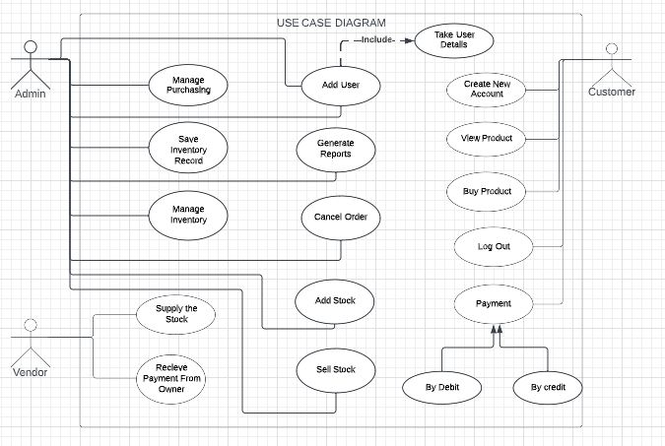

**3.3.2 Activity Diagram**

### 

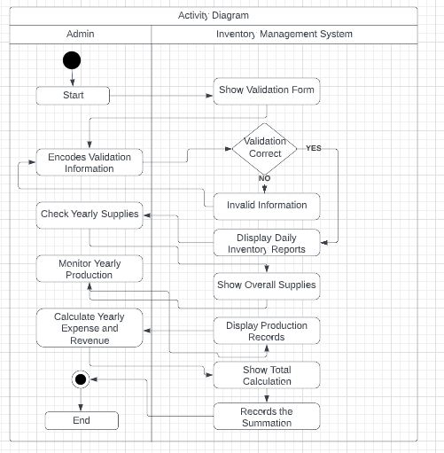

**3.4.1 Sequence**

### 

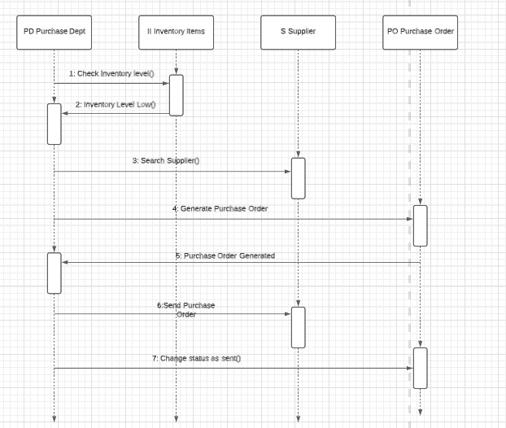

#### 3.4.2 Collaboration

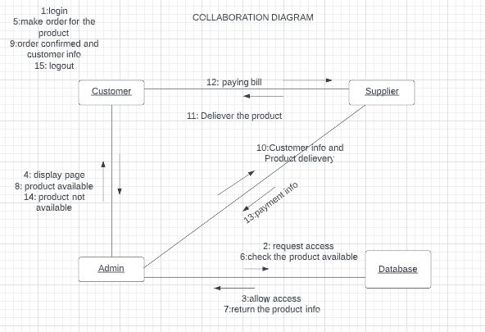

**3.5 Class Diagram:**

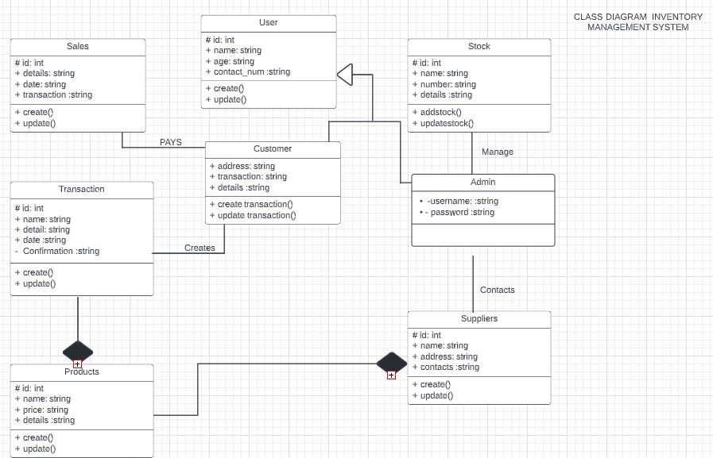

**3.5.1 State Chart**

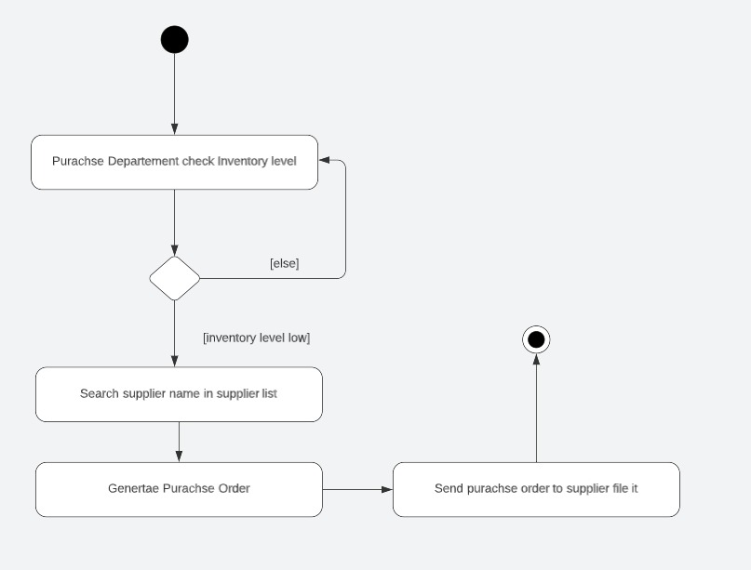

#### 

#### 3.7 Non-Functional Requirements

Non-Functional Requirements of Our Project are as follow:

1. Security
2. Reliability’
3. Maintainability
4. Portability
5. Extensibility
6. Reusability
7. Compatibility
8. Resource Utilization

#### 3.8 Performance Requirements

In order to maintain an acceptable speed at maximum number of uploads allowed from a particular customer as any number of users can access to the system at any time. Also the connections to the servers will be based on the attributes of the user like his location and server will be working 24X7 times

#### 3.9 Interface Requirement

Various interfaces for the product could be

1. Login Page
2. Dashboard
3. Product Inseretionnscreen and dislaying.
4. If the user want to create invoice it will generate it easily.

#### 4.0 Application GUI Interface

